Mantra |  | English Interpretation
Ganesh ji ki Aarti (Hindi) | English | Prayer to Lord Ganesha
जय गणेश जय गणेश,  जय गणेश देवा ।  माता जाकी पार्वती,  पिता महादेवा ॥  एक दंत दयावंत,  चार भुजा धारी ।  माथे सिंदूर सोहे,  मूसे की सवारी ॥  जय गणेश जय गणेश,  जय गणेश देवा ।  माता जाकी पार्वती,  पिता महादेवा ॥  पान चढ़े फल चढ़े,  और चढ़े मेवा ।  लड्डुअन का भोग लगे,  संत करें सेवा ॥  जय गणेश जय गणेश,  जय गणेश देवा ।  माता जाकी पार्वती,  पिता महादेवा ॥  अंधन को आंख देत,  कोढ़िन को काया ।  बांझन को पुत्र देत,  निर्धन को माया ॥  जय गणेश जय गणेश,  जय गणेश देवा ।  माता जाकी पार्वती,  पिता महादेवा ॥ | Jai Ganesh, Jai Ganesh, Jai Ganesh Deva  Mata Jaaki Parvati Pita Mahadeva  Jai Ganesh, Jai Ganesh, Jai Ganesh Deva  Mata Jaaki Parvati Pita Mahadeva  Ek Dant Dayavant, Chaar Bhuja Dhaari  Maathe Pe Sindhoor Sohe, Muse Ki Savari  Paan Chadhe, Phul Chadhe, Aur Chadhe Meva  Ladduan Ka Bhog Lage, Sant Kare Seva  Jai Ganesh, Jai Ganesh, Jai Ganesh Deva  Mata Jaaki Parvati Pita Mahadeva  Andhan Ko Aankh Det, Kodhin Ko Kaaya  Baanjhan Ko Putra Det, Nirdhan Ko Maaya  Surya Shaam Sharan Aye, Safalki Je Seva  Mata Jaaki Parvati Pita Mahadeva  Jai Ganesh, Jai Ganesh, Jai Ganesh Deva  Mata Jaaki Parvati, Pita Mahadeva | Hail to you O, Lord Ganesha, I bow before you.  Salutations to the son of Mata Parvati and Lord Mahadeva.  Salutations to the one who has one tusk, and four hands,  The sindhoor adorns his forehead, and he is mounted on his Mooshak.  Here's offering the betel leaves, the flowers and the Mewa  Here's offering the laddoos, as the saints serve him.  Hail to you O, Lord Ganesha, I bow before you.  Salutations to the son of Mata Parvati and Lord Mahadeva.  He gives vision to the one who is blind, and good health to the one who is ill  He showers his blessings on the one who is childless, and wealth on the poor  As we pray throughout the day and in the evening, let our prayers bear the fruits  Salutations to the son of Mata Parvati and Lord Mahadeva.  Hail to you O, Lord Ganesha, I bow before you.  Salutations to the son of Mata Parvati and Lord Mahade
Gayatri Mantra ( Hindi) | English | English Interpretation
ॐ भूर्भुवः स्वः । तत्सवितुर्वरेण्यं  भर्गो देवस्यः धीमहि । धियो यो नः प्रचोदयात् ।। | Om Bhu Bhurvaḥ Swaḥ  Tat-savitur Vareñyaṃ  Bhargo Devasya Dheemahi  Dhiyo Yonaḥ Prachodayāt | General meaning: We meditate on that most adored Supreme Lord, the creator, whose effulgence (divine light) illumines all realms (physical, mental and spiritual). May this divine light illumine our intellect.  Word meaning: Om: The primeval sound; Bhur: the physical body/physical realm; Bhurvah: the life force/the mental realm Swah: the soul/spiritual realm; Tat: Father (God); Savitur: the Sun, Creator (source of all life); Vareñyam: adore; Bhargo: effulgence (divine light); Devasya: supreme Lord; Dhīmahi: meditate; Dhiyo: the intellect; Yo: May this light; Nah: our; Prachodayāt: illumine/inspire.
Shani (Beej) Mantra (Hindi) | English | Lord Shani Seed Mantra English Interpretation
ॐ प्राँ प्रीं प्रौं  सः शनैश्चराय नमः ॥ | Om praam preem praum sah shanayishraya namah | Ode to Lord Shani to be in my favour and calm my senses
Markatesh Mahotsaya Mantra | English | English Interpretation
ॐ kleen मर्कटेश महोत्साह सर्व vyadhi विनाशन ।  शत्रून संहर मां रक्षा श्रियं दापय dehi मे kleen ॐ ॥  ( Could not locate the exact mantra as taught to me on the net – this was the closest with some words (in English) keyed in) |  | Prayer to Lord Hanuman – to destroy obstacles, Kill the enemy and protect me-
Bagulamukhi Mantra | English | English Interpretation
ॐ  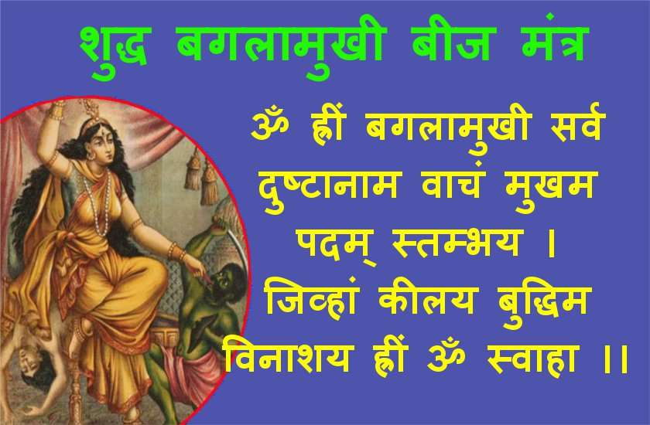 |  | O Mother Baglamukhi, I take refuge in you. Let the speech, feet and organs of my enemy is stilled and let his intelligence be disabled so that he does not move further to harm me.
Guru Mantra (hindi) | English | English Interpretation
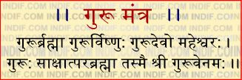 | GururBrahma GururVishnu GururDevo Maheshwaraha  Guru Saakshaat ParaBrahma Tasmai Sri Gurave Namaha | - Guru is the Creator (Brahma), Guru is the Preserver(Vishnu), GuruDeva is Destroyer(Maheshwara)  - Guru is the absolute (singular) Lord himself, Salutations to that Sri Guru
Outro Couplet | English | English Interpretation
जीवन में असली उड़ान अभी बाकी है,  हमारे इरादों का इम्तिहान अभी बाकि है,  अभी तो नापी है सिर्फ मुट्ठी भर जमीन,  अभी तो नापने के लिए सारा आसमान बाकी है. |  | The real flight is still to be…  I still have to take the exams of my intentions…  I have just measured a fistful of earth…  I still have to measure the entire sky!

Please note that some of the lyrics are having wordings slightly different from the ones used in the video. That is because some of these are sourced from internet and different sources have slightly different words ( you can Google and check…)! Finally, there is only one perfection – that of doing!

